FEDERAL STATE AUTONOMOUS EDUCATIONAL INSTITUTION OF HIGHER EDUCATION

ITMO UNIVERSITY

Report

on the practical Lab 1

“*India Population*”

Performed by

*Abizer Safdari*

*J41321c/J4134c*

St. Petersburg

2021

1. **Determine the «survival» rates independently for men and women for all age groups (“0-4” -> “5-9” -> “10-14” ...) according to 2000-2005 years (data for Russia or any other country.**

*All equations are according to (2000 - 2005 years). The input data on the right of the equation and the output data is on the left of the equation.*

Survival_rate(“0-4” -> “5-9”) = “5-9”_2005 / “0-4”_2000

INPUT: population of age group in following year, population of th previous age group in the previous year.

OUTPUT: survival rate

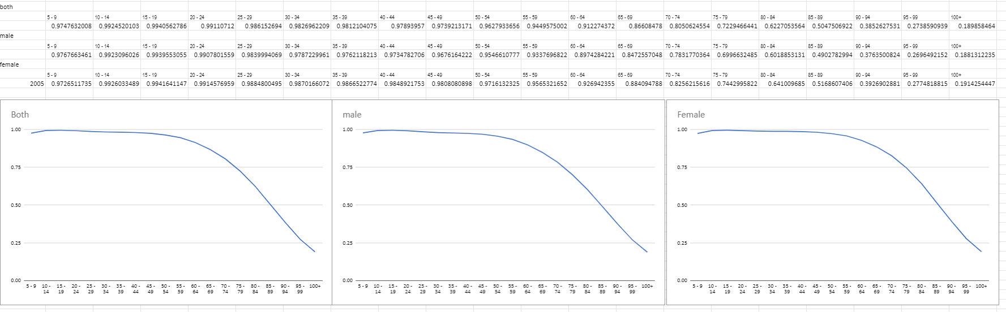

The survival rates of all 3 category are similar and they start to drop around 45-49.

1. **Determine the fertility rate for women in the age category “20- ... -39”**

Fertility_rate = number_of_children(0-4years) / sum_of_women(20-39years)

*The input data on the right of the equation and the output data is on the left of the equation*

INPUT: number of children born in a year, sum of reproductive women in a year.

OUTPUT: fertility rate

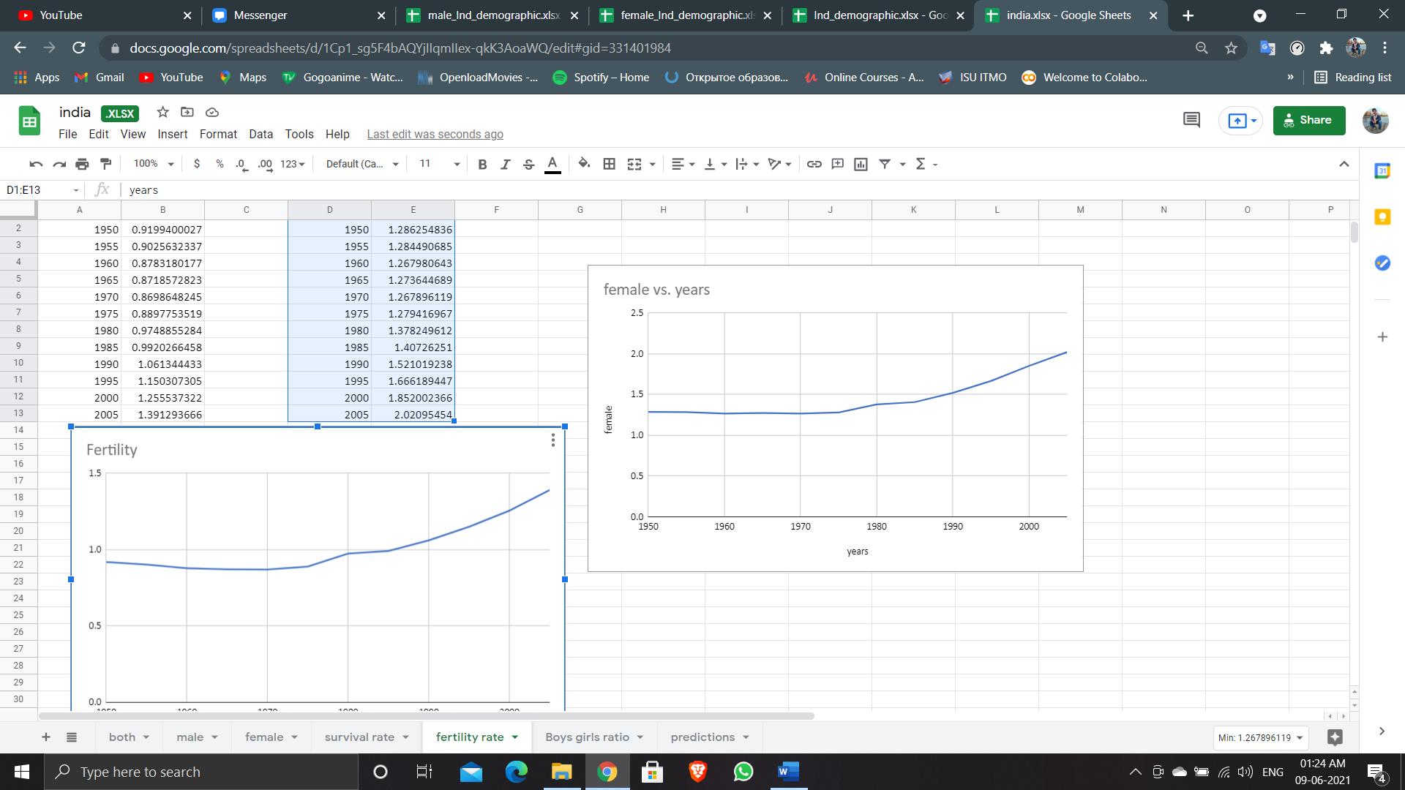

The Fertility rate was gradually increasing

1. **Calculate boys/g.irls ratio for newborn children**

boys/girls ratio = number_of_boys(0-4years) / number_of_girls(0-4years)

*The input data on the right of the equation and the output data is on the left of the equation*

INPUT: number of boys born, number of girls born

OUTPUT: boys/girls ratio

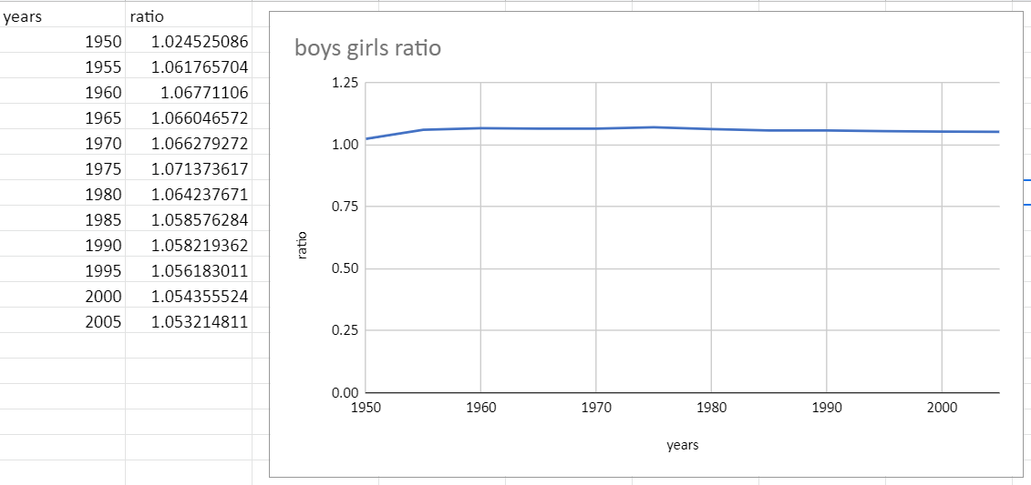

The number of girl child born is slightly lower then number of boy child.

1. **Predict the change in the country's population and demographic profile for 100 years and compare with existing predictions!**

The prediction was done by gender, i.e. male predictions and female predictions were done separately.

female_new_babies(0-4) = female_fertility_rate(*from previous year*)*sum_of_women(*20-39years from previous year*)

*The input data on the right of the equation and the output data is on the left of the equation*

Then for the corresponding age groups

Population_in_AgeGroup = Survival_rate_in_AgeGroup*population_of_previous_AgeGroup_in_previous_year

INPUT: fertility rate, sum of fertile women in previous year, survival rates for all age groups, population of new babies in previous

OUTPUT: Population in year

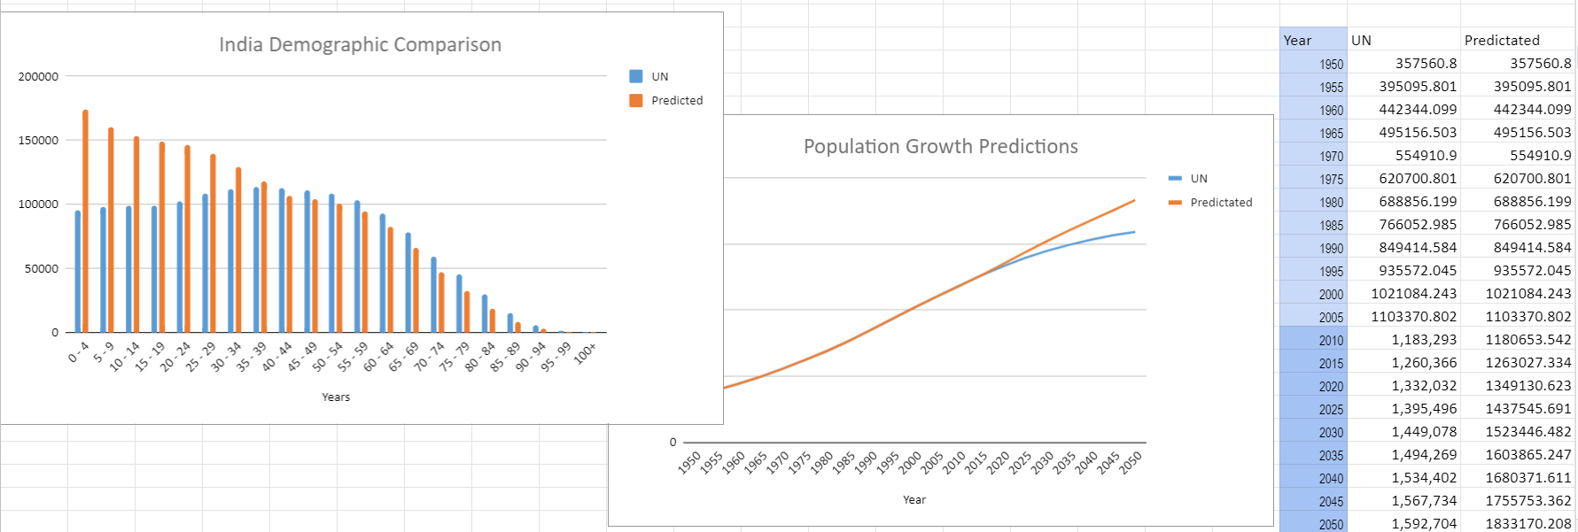

The predictions done are almost similar to the predictions done by the UN.